Project Design Phase-II
Data Flow Diagram & User Stories

Date | 09 March 2026
Team ID
Project Name | Visualizing Housing Market Trends: An Analysis of Sale Prices and Features using Tableau
Maximum Marks | 4 Marks

1. Data Flow Diagram (DFD)
A Data Flow Diagram (DFD) is used to visually represent how data moves through a system. It shows:
- Where data comes from
- How the data is processed
- Where the data is stored
- How results are delivered to users
In this project, the DFD explains how housing market data flows from datasets to Tableau dashboards and finally to users through a Flask web application.
2. DFD Level-0 (Context Diagram)
Explanation
The Level-0 DFD represents the entire system as a single process.
External Entities
1. Data Sources
The system collects housing data from:
- Kaggle housing dataset
- CSV or Excel files
- Real estate property databases
These datasets contain information such as:
- Sale price
- House age
- Bedrooms
- Bathrooms
- Floors
- Renovation year
- Basement area

2. Housing Market Analysis System
The main system processes the data using:
- Data preprocessing
- Data visualization in Tableau
- Dashboard creation

3. Users
The system is used by:
- Real estate analysts
- Marketing teams
- Company executives
- Property investors
These users interact with the dashboard to analyze housing trends.

4. Output
The system produces:
- Interactive Tableau dashboards
- Housing market insights
- Visualization of property price trends

Process Explanation
1. Data Collection
Housing datasets are collected from sources such as:
- Kaggle
- Real estate databases
- CSV / Excel datasets

2. Data Preparation
The dataset is cleaned and transformed.
Tasks include:
- Removing missing values
- Handling duplicates
- Converting data types
- Creating calculated fields
Example calculated fields:
- House Age = Current Year − Year Built
- Years Since Renovation
- Price per Square Foot

3. Data Visualization
The prepared dataset is imported into Tableau Desktop.
Several charts are created, including:
- Bar charts
- Histograms
- Pie charts
- Scatter plots
These visualizations help analyze relationships between housing features and prices.

4. Dashboard Development
All visualizations are combined into an interactive Tableau dashboard.
Features include:
- Filters
- Tooltips
- Interactive graphs

5. Dashboard Publishing
The dashboard is published on:
- Tableau Public
or
- Tableau Server
This generates an embed link.

6. Web Integration
The dashboard is embedded into a Flask web application.
Flask allows users to access the dashboard through a browser.

7. User Interaction
Users interact with the dashboard to analyze:
- Housing price trends
- Renovation impact on property value
- Distribution of house features

4. System Workflow Diagram
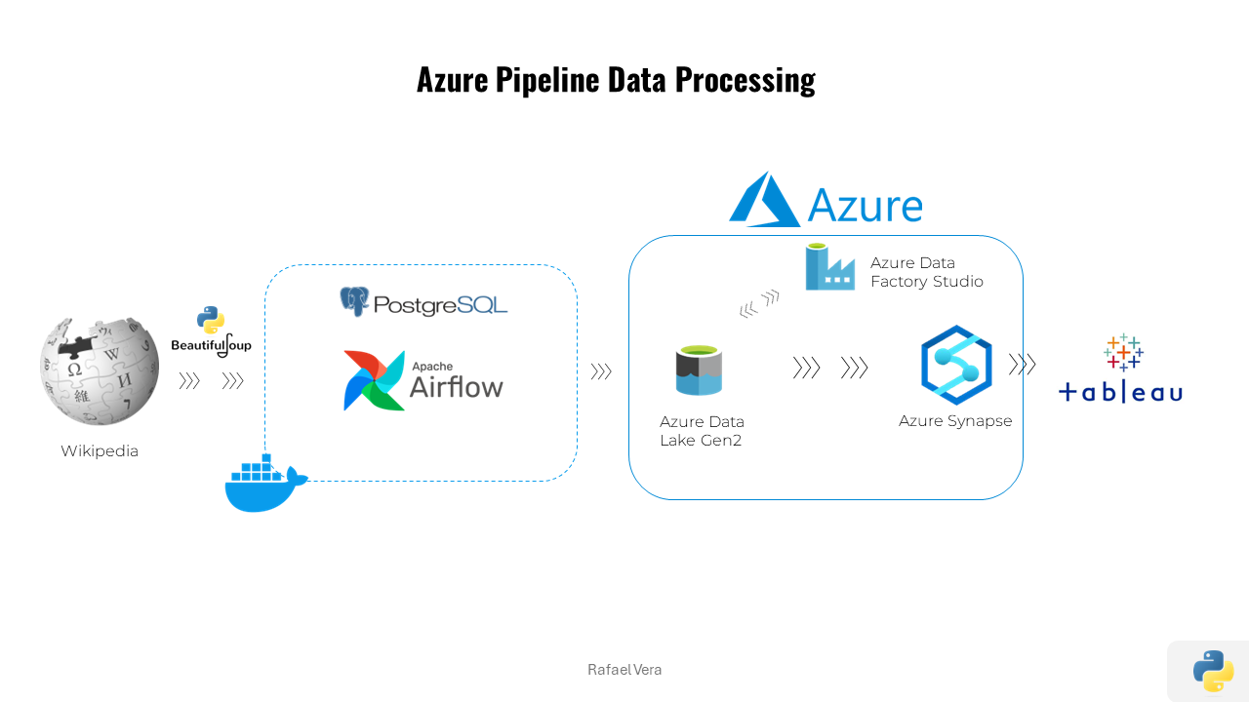
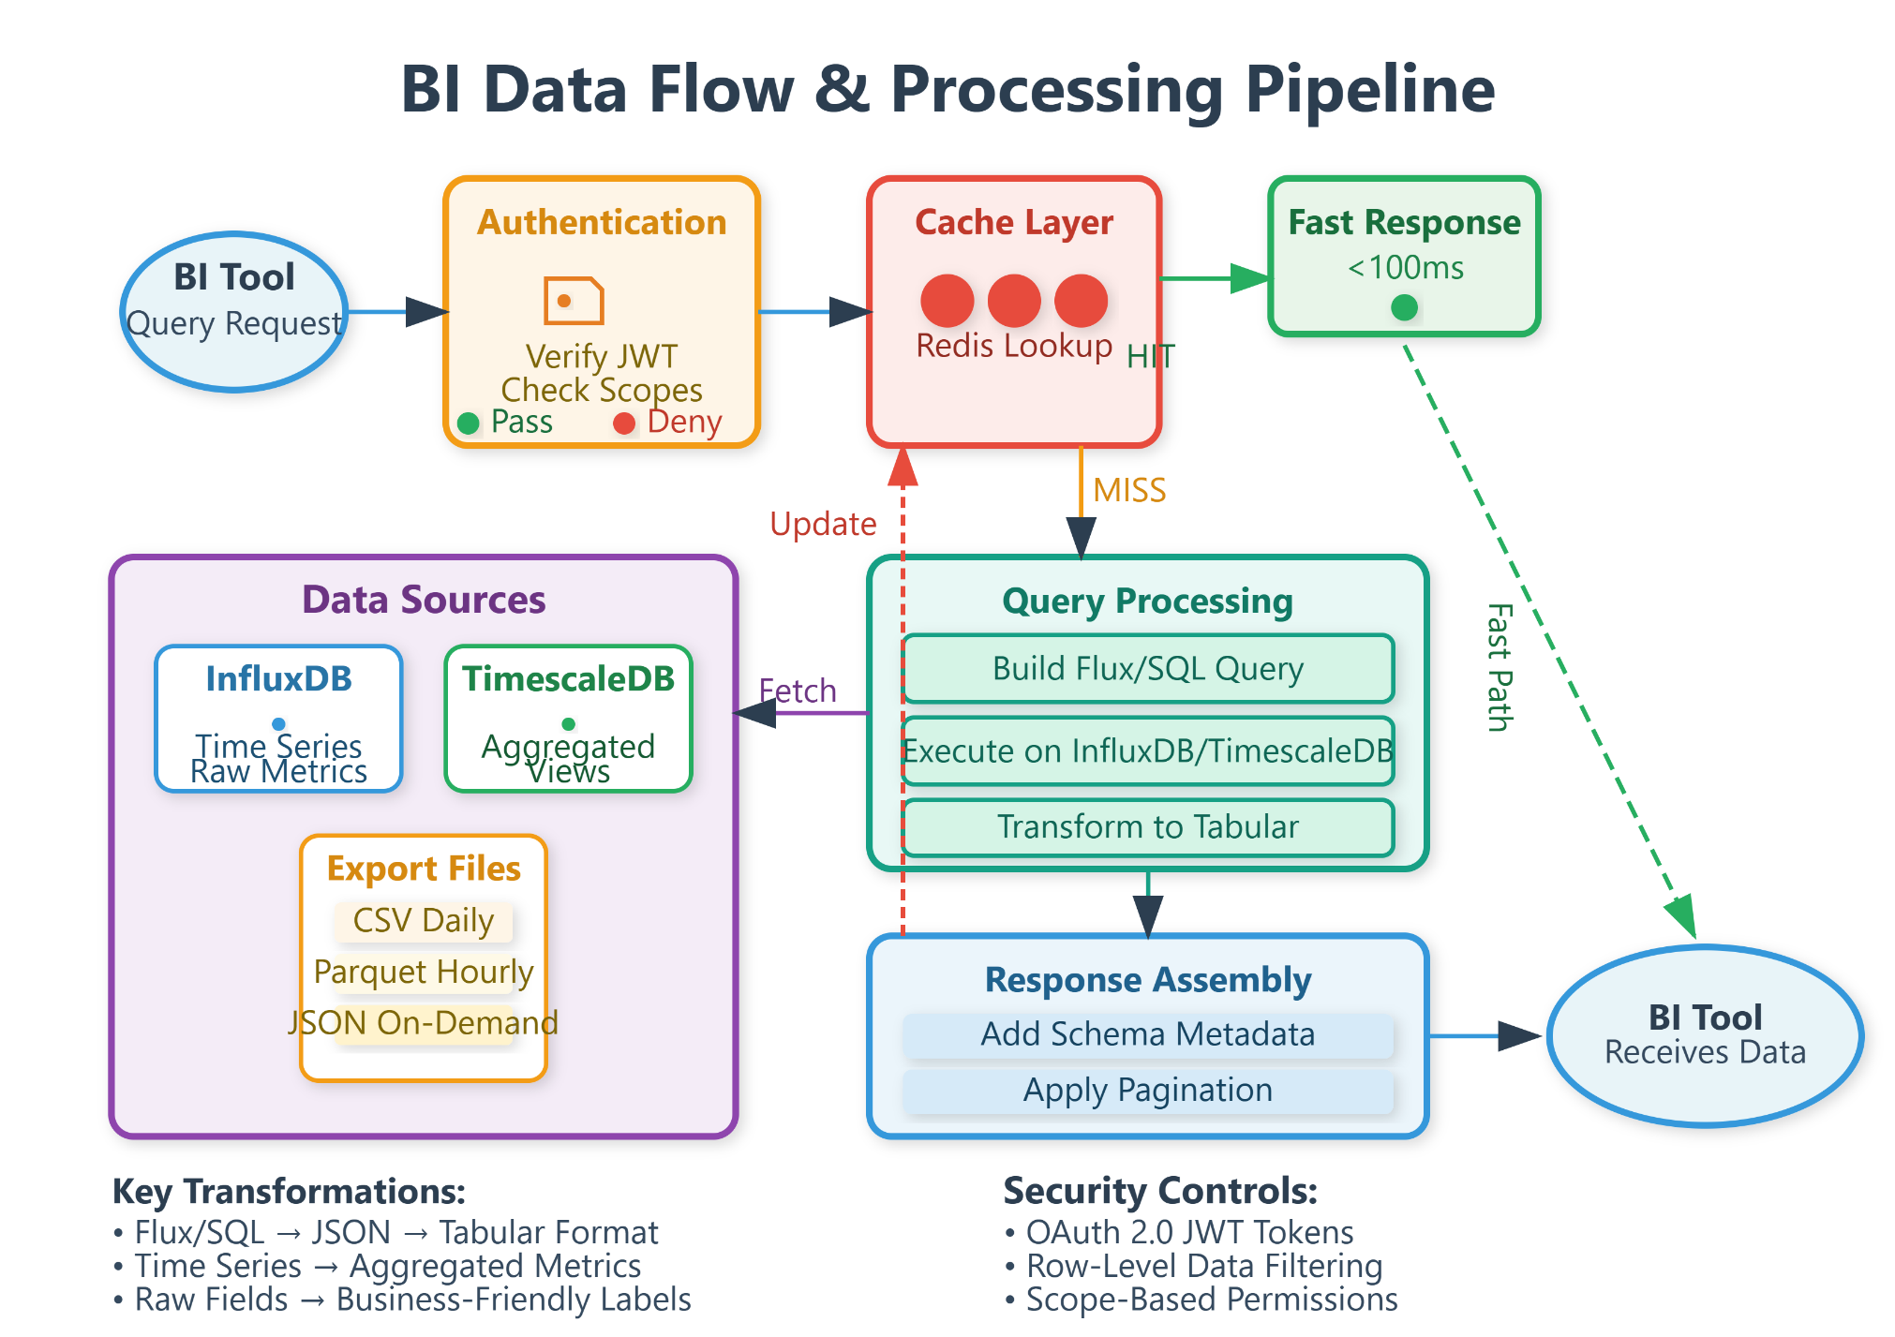

4
Workflow Steps
- Collect housing dataset
- Clean and preprocess data
- Connect dataset to Tableau
- Create visualizations
- Develop interactive dashboard
- Publish dashboard on Tableau Public
- Integrate dashboard with Flask
- Users access dashboard through web browser

User Stories
Use the below template to list all the user stories for the product.
User Type | Functional Requirement (Epic) | User Story Number | User Story / Task | Acceptance criteria | Priority | Release
Real Estate Analyst | Renovation Analysis | USN-1 | As an analyst, I want to view housing price trends | I can view interactive charts | High | Sprint-1
Real Estate Analyst | Feature Analysi | USN-2 | As an analyst, I want to analyze renovation impact on house prices | Renovation vs price chart is visible | High | Sprint-1
Marketing Team | Trend Analysis | USN-3 | As a marketing team member, I want to analyze housing features | I can compare bedrooms, bathrooms and floors | Medium | Sprint-2
Marketing Manager | Decision Support | USN-4 | As a manager, I want to identify housing demand trends | Dashboard filters work correctly | Medium | Sprint-1
Executive | Login | USN-5 | As an executive, I want summarized insights | I can see KPI summary charts | High | Sprint-1
Web User | Dashboard | USN-6 | As a web user, I want to access the dashboard online | Dashboard loads in browser | High | Sprint-2
Administrator | Data Management | USN-7 | As an admin, I want to update housing datasets | I can upload new datasets | Medium | Sprint-2

